**INFYU Labs Assignment**

Developer: Dutta Avinash Atchyutuni

Assignment - to display and generate random frames from given video

Description – The task given was to make an interactive GUI, where the user can give a path of a .mp4 video and expects a number of randomly generated frames within the video.

Date of submission - 06-May-2022

**Algorithm**

* The path given by the user has to be extracted from the GUI.
* We must then check if the path contains ‘output’ and ‘random’ folders present.
* If yes, we must ask the user if he wants to retain the contents of the folders.
* If no, we must create the respective folders in the path.
* If step3 is true, we must to append the newly generated frames from the given video into the ‘output’ folder
* If false, we must delete the contents of the folder and add the frames into the empty folders.
* We then ask the user, the number of images that needs to be generated at random.
* Once the number has been given, we then generate the random images and place them in the ‘random’ folder.
* The option is then given to user to view the images.
* If yes, display the images in the GUI
* If no, close the GUI

**GUI description:**

1. The user is first presented with the below window once the code is executed

**If the user would like to proceed to next page, he must check the ‘do you want to continue checkbox’ and click on submit**

**If no, he can simply click on submit and GUI will close**

1. Once the user proceeds, he is greeted with the 2nd page . which he has to enter the path of the video (.mp4). The path should be of a local directory and **not web link.**

it should be separated with ‘\’:

sample path : C:\Users\UserName\Documents\Python lessons\Data Statistics\Test.mp4

**Note: the path must not contain any quotes**

1. The user then has to choose, whether if he/she wants to retain the contents of the folders. If yes he must check the ‘delete the previous contents?’ box and click on submit.

If no, he has to click on submit without checking the box.

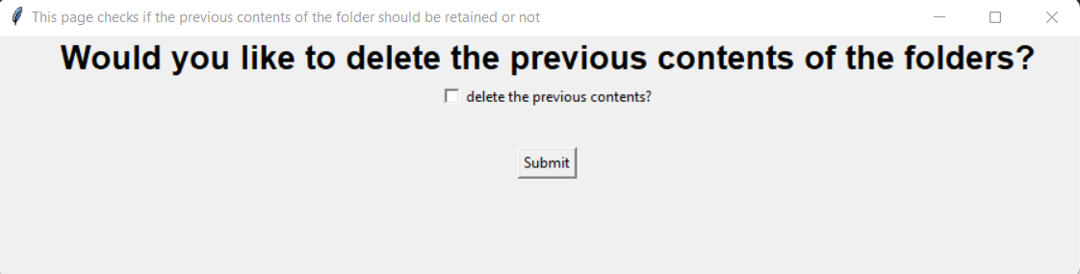

1. Once done, the user has to enter the number of random images he wants to generate and click on submit.

The input must be a number

1. The user then displayed with an option to view the images, along with links on both the random folder and output folder. Which he can click to view the contents of the folder.

If the user wishes to view the contents, he must check ‘do you want to view the images ’box and click on submit.

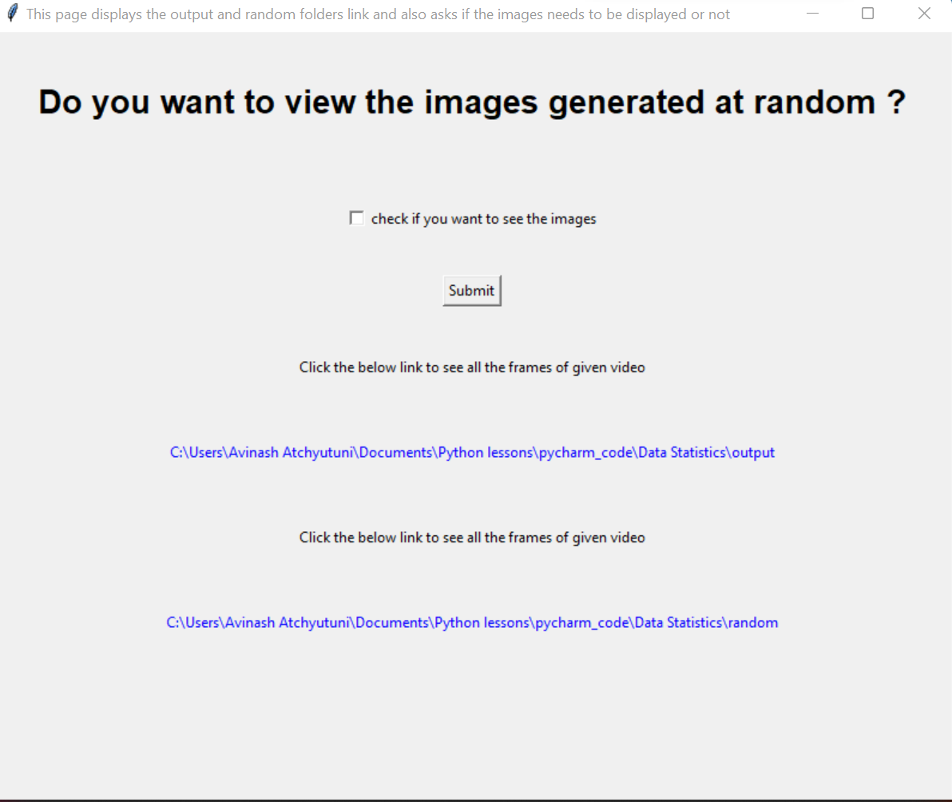

1. Finally, the user is displayed with the number (given by the user) of random images.A picture containing text

   Description automatically generated

Requirements:

The following libraries must be installed in the user’s system, the code as to run

1. os
2. cv2
3. glob
4. random
5. shutil
6. from tkinter *
7. datetime
8. webbrowser
9. PIL

Github link: <https://github.com/Avinash-Atchyutuni/Assignment_INFYU_Labs/blob/5a625289d7061b0e9b3aca679dfd2702bfdb2cb3/Assignment_Final.py>